**Wood Panel Wallpaper in Blush**

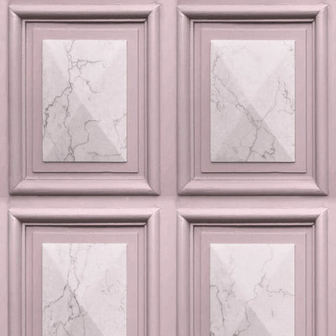Wood panel wallpaper in blush offers a subtle, soft elegance that combines the natural beauty of wood with a gentle, pastel hue. This wallpaper brings warmth and a touch of color to any space, creating a welcoming and serene atmosphere. The blush tone adds a refined, modern twist to the rustic charm of wood panels, making it an ideal choice for those seeking a calming yet stylish look. Whether used in bedrooms, living rooms, or even bathrooms, it effortlessly enhances the aesthetic of any room with a harmonious balance of nature-inspired textures and contemporary color.